Gender Bias in Science, Technology, Engineering and Mathematics

The Divide

Team #4

Florida State University

LIS3201

Research Progress Report

**Problem Statement**

Your revised problem statement and purpose of study. **Make sure every argument of yours needs to be backed up by appropriate sources (APA 7th style in-text citations needed).** You need to incorporate the comments from instructors and highlight your changes.

When considering the domain of Science, Technology, Engineering, and Mathematics (STEM) university cohorts, a digital divide exists within the gender distribution of students. In specific, there are a disproportionate number of men enrolled in STEM majors compared to the female population size. As a result of a trickle-down-like effect, the demographics of STEM workplaces is impacted: According to the U.S. Census Bureau, in 2019, women made up 48% of all workers, yet only accounted for 27% of STEM related jobs (Martinez & Christnacht, 2021). The discrepancy can be attributed to the following logical track: Universities are institutions that prepare, educate, and equip students with the foundational skills necessary to enter the workplace as productive employees. As our society grows more technocratic, the number of employers that value and therefore hire employees with a STEM background is increasing. For example, McKinsey & Company estimates that between 2017 and 2030, the potential job growth for STEM professionals is near 40% (Lund et al.).

As STEM students of Florida State University, we believe this research is pertinent to the success and outcomes of our undergraduate alumni. If university faculty can better understand the reasons that some students do not enroll in certain degree tracks, they may be able to remedy societal biases. In order to address those preconceived notions, university administration must first understand where gaps exist and subsequently investigate why. For these reasons, we have designed a study that explores the relationship between the gender of FSU undergraduate students and their experience within the STEM programs at FSU.

**Significance of Study**

Your revised significance statement. **Make sure every argument of yours needs to be backed up by appropriate sources (APA 7th style in-text citations needed).** You need to incorporate the comments from instructors and highlight your changes.

The modern age: our finances are managed by networks of highly sophisticated algorithms, our homes are continually becoming a place to share with the Internet of Things, and soon, our laws will be largely policed by computers (Eggers et al., 2017). As all sorts of technologies continue to engrain themselves in society, it follows that whoever engineers the products has a large stake in the fabric of our lives. Logically, we need diverse representation if we ever hope to achieve any semblance of equality, or equity, between the members of our society. As stated, our group believes that the root of the growing imbalance in STEM gender representation worldwide can be tracked down to biases in education. To be clear, we believe that the skills and demographics of graduates who concentrate in STEM have a direct impact on the skills and demographics of employees who concentrate in STEM occupations. In order to address the gaps in the distribution of gender, research must be conducted to observe where the discontinuities exist and why they take place. Our research aims to conduct a close investigation into the relationship between gender and STEM participation in education at Florida State University.

For many reasons, we believe that increasing diversity in the STEM programs at FSU is a mutually beneficial relationship for both the graduate and the university. For one, increasing diversity and actively recruiting interest from communities that are underrepresented in the STEM workforce can directly impact the culture of a classroom. By allowing new perspectives, students may introduce novel problem solving strategies, which may lead to unique research opportunities for the university. Additionally, if the culture of a classroom diversifies, students who may have previously felt uneasiness with their participation in STEM may begin to feel more comfortable in their environment. For a university, this can lead to higher satisfaction within the program. An increase in satisfaction can influence the number of students that enroll in a program as well as the retention rate for a program; two important factors for ranking the quality of a university’s department.

Increasing diversity within STEM programs is also beneficial for universities after a student graduates, as employers are actively looking for diverse workers. A report conducted by the Harvard Business Review revealed that of 1,115 North American companies, 74% report that they track the diversity of new hires (Brown, 2021). A university that produces diverse talent is likely to create highly recruitable job candidates, which can reflect well on the quality of the education a university provides.

Our hope is that once a disparity has been discovered and sufficiently examined, a university may deploy targeted campaigns to engage with underrepresented demographics. Furthermore, an active effort to investigate and mediate this divide at our university can lead to replicable observations for supplementary research being done at other universities.

**Research Questions**

RQ1: What effect(s) does the gendered digital divide have on the educational experience of FSU undergraduates?

RQ2: How do students at FSU recognize the Digital Divide between the number of women in STEM vs the number of men in STEM?

# Environmental Scan

In the introduction of your environmental scan, you need to provide a brief introduction of your topic based on previous literature. And then talk about how your environmental scan is organized. **APA 7th style in-text citations are needed for every argument you make.** Organize your scan under 3-4 subsections. In the conclusion section of your environmental scan, you need to conclude the main findings from all of the subsections, and link them to the significance or unique contributions of your study. You need to incorporate the comments from instructors and highlight your changes***.***

**Introduction**

The mark of a generation is largely tied to the tools they utilize. In the 19th century, the Industrial Revolution and coal-powered steam engines changed nearly every aspect of urban life, and similarly, the 21st century has its own toolage to thank for life-changing advances. In the modern world, society has largely normalized the interaction between humans and computers. It has become increasingly common to adopt technology in the home. For instance, in 2015, the National Center for Education Statistics (NCES) reported that around 85% of children ages 3 to 18 lived in households with access to a computer [(KewalRamani et al., 2018)](https://www.zotero.org/google-docs/?broken=ztcnuo). As such, 15% of this population has limited interaction with technology. The concept of a gap existing between the technology haves and the technology have-nots is commonly referred to as the digital divide. When considering the digital divide, it is common to cluster populations based on different classifiers. For the purposes of this study, the gendered digital divide will be analyzed. That is, this study aims to analyze the discrepancies between male technological adopters and female technological adopters. We believe that the effects of the digital divide can be associated with stereotypes surrounding women and their interaction with technology, as well as academic policies and practices, which can in turn affect outcomes for employability and workplace relations for the digitally marginalized.

**Gender Norms**

The barriers for women to become involved with technology often reveal themselves through stereotypes concerned with the differences between men and women. These gender stereotypes can vary between cultures. For example, we will take note of the stereotypes about women in India who use cell phones. In 2018, a Harvard study determined that mobile phone usage for women in India carries cultural significance (Barboni et al., 2018). The research found that owning a mobile phone is viewed as a risk to the reputation of women, and their adoption of mobile phones is seen as a threat to their purity. For married women, extensive mobile phone usage was found to be a sign that a woman is not taking proper care of her children (Barboni et al., 2018). These biases can lead to women neglecting the use of technology, but they can also be internalized and prompt women to believe that they are less skilled than their male counterparts. To illustrate that point, when asked to rate their ability in utilizing internet tools, men are nearly twice as likely to describe themselves as having an excellent grasp (Liff & Shepherd, 2004). Similar research reveals that female students report ratings of feeling less comfortable and less confident about computer usage when compared to their male classmates' responses. These same women expressed anxiety at the prospect of using computers, which they proclaimed led to feeling “inhibited to pursue careers in technology” (Cooper & Weaver, 2003). The biases concerning women’s digital competency may provide an explanation for the lack of women entering Science, Technology, Engineering, and Mathematics (STEM) fields.

**Education**

Another explanation for why women make up less of the STEM workforce than men can be attributed to biases in education. In 2019, the Programme for International Student Assessment (PISA) surveyed the academic performance of 15 year old students in 67 countries. The survey found that 15 year old boys outperformed their female classmates in science assessments in 22 countries, while 15 year old girls outperformed their male classmates in science assessments in 19 countries (Mostrafa, 2019). For the remaining 26 countries, the performance differences in science assessments between boys and girls were deemed to be statistically insignificant. Across the board, the overall performance between 15 year old boys and girls was determined to be similar. As such, there is no clear intellectual advantage to indicate that men are more likely to aspire to scientific academic and post-academic pursuits due to their juvenile academic performance.

Yet, a disparity exists between men and women enrolled in STEM programs in higher education. On average, estimations have revealed that in 2019, 49% of women were expected to complete a university STEM degree. However, in reality, only 28% of women enrolled and completed a STEM degree (Mostrafa, 2019). This relationship reinforces the notion that women are less likely to participate in STEM programs. As far as computing degrees are concerned, McKinsey & Company found that 19% of students who received a computing degree were women (Lund et. al., 2019).

**Workplace**

The natural progression for college graduates is to seek employment in their field of expertise. Thus, it is logical that students who specialized in STEM fields during their education tend to gain employment in STEM positions. As a result, the gendered digital divide persists outside of academia and seeps into the workplace. In specific, a clear disparity arises between the gender split of male and female STEM workers. For example, McKinsey & Company reported that women hold only 26% of computing jobs in the United States, demonstrating a monstrous gap between the number of men employed in one STEM field versus the number of women (Lund et. al., 2019). Additionally, the trend of using and maintaining technology in the workplace results in the expectation that workers know how to use and are comfortable interacting with technology. In the near future, two of the top ten most sought after skills by employers will be “technology use, monitoring and control” as well as “technology design and programming” [(World Economic Forum, 2020, p. 36)](https://www.zotero.org/google-docs/?broken=OYn1tu).

Consequently, a large percentage of college educated women are at risk of not becoming equipped with the necessary skills to succeed in a changing job market. The shift to algorithmic and virtual workplace solutions is not only changing the soft skills that employers are looking for, but it is also disrupting the job market as a whole. The U.S. Bureau of Labor Statistics (BLS) employment projections report that on average, between 2019 and 2029, all occupations will see a 3.7% rise in job growth [(Ice & Zilberman, 2021)](https://www.zotero.org/google-docs/?broken=p8pmiG). The same projections noted that STEM related employment will see an 8.0% growth, more than doubling that of the job market average. Other sources estimate numbers for potential growth in STEM-related jobs as high as 37% by 2030 (Lund et. al., 2019). These changes will greatly benefit the digitally literate population, but the same cannot be said for the other portion of the digital divide. In essence, millions of women will lose the qualifications necessary to become employed in the changing world.

**Conclusion**

The digital divide is a permeating misfortune. One observable manifestation of the digital divide is that of gender. Our study aims to examine whether the array of stereotypes surrounding gender norms lead to biases in the academic experiences and outcomes of women. We believe that documenting and researching these experiences is important, as the result of women being less involved in STEM education can negatively impact their likelihood to be hired for STEM roles after graduating. These observations are valuable due to how fast the workplace is adopting technology and recruiting for more technically capable employees.

**Methods**

**Data Collection Methods**

Provide your finalized choice of data collection method here. You can be more specific of the detailed data collection method you’d like to use (e.g., paper survey, on-line survey, semi-structured interview), and provide brief reasons. However, you DON’T need to talk about the methods you won’t use in your study (no need to provide the cons of other methods). You need to incorporate the comments from instructors and highlight your changes***.***

The research method we chose for examining the gendered digital divide at Florida State University was to survey undergraduate students at the university. We chose to survey students because the medium is effective in describing characteristics of large populations, which allows us to explain the behaviors that correspond to a 30,000+ population of people. Additionally, the survey can be distributed online. Given the circumstances of the COVID-19 pandemic, as well as the ease of distribution, we were able to reach our sample population of students in a timely manner. In order to execute, we contacted students through various social media, over our course forums, and in our respective student group chats. We also reasoned that there were supplementary benefits to surveying students online. An online survey is anonymous and time efficient, which can inspire more honest responses. We also considered interviewing survey respondents. In order to do so, we had to have completed our survey or had an appropriate number of respondents in suitable time, which we were unable to do.

# Population and Sample

Provide your finalized choice of population and sampling techniques here. No need to include techniques you won’t use. You need to incorporate the comments from instructors and highlight your changes.

For our research, we are targeting the population of undergraduate students at FSU. To better understand how the gender digital divide manifests itself in a university, we decided it would be best to collect information from all students, regardless of whether they went into a Science, Technology, Engineering, or Mathematics track.

As all of the members of our group are enrolled in the College of Communication and Information, it will be easy to access students that are enrolled in our college. For this reason, we think an appropriate sampling technique will be convenient. The students enrolled in our college are a combination of those enrolled in a STEM track, and those that are not. For instance, the College of Communication and Information offers STEM degrees in Information Technology or Information, Communication, and Technology and also, non-STEM degrees in Communication. It will be easier to access and reach survey participants if we can reach out to them directly, through our professors, or in-class. This sampling technique lends itself to bias because of the lack of a diverse population. If we want our research to represent the entire population of undergraduate students, we cannot limit our sample to a single college. Additionally, we will utilize the voluntary sampling technique. Our surveys will likely rely on participants being willing to take the time to sit down and fill out the form. This sampling technique can also introduce bias, as participants who are passionate about the subject are more likely to be concerned with the topic at hand and go through the effort of filling out a form. Our research is meant to be representative of the entire population of FSU undergraduates, thus we are still concerned with the experience of students who are dispassionate about the gender digital divide.

# Recruitment Site and Strategy

Specify your recruitment site and strategy. Detailed plans that you really employed are expected. You need to incorporate the comments from instructors and highlight your changes.

The supplies that we needed to conduct our research included access to the Internet and their respective tools for creating and distributing surveys. In order to conduct our research and collect user generated responses, we utilized the Qualtrics experience management software. Qualtrics was chosen as the medium for survey creation and survey taking because of the abundance of features that we have free access to as Florida State University students. As for our recruitment strategy, we spread the word and asked for respondents on various social platforms. Some of the websites used were student groups on GroupMe, Discord, Facebook, Instagram, and LinkedIn. We visualized our data with Excel. Additionally, we not only recruited participants by spreading the survey through social media but through other online mediums as well. We knew that FSU students were present in their online lectures, so we also recruited survey takers on Zoom and Blackboard Collaborate lecture streams. By casting a wide net of the population, we hope to recruit a wide range of different participants.

# Data Analysis and Collection

**Demographic Description**

Total Number of respondents: 75

Final Sample Size: 64

Male: 28

Female: 30

Non-binary: 5

Other: 1

Abandoned the survey: 11

| **Gender** | **% of population** |
| --- | --- |
| Male | 44.62% |
| Female | 46.15% |
| Non-binary | 7.69% |
| Other | 1.54% |

| **Class** | **% of population** |
| --- | --- |
| Freshmen | 20.00% |
| Sophomore | 23.08% |
| Junior | 32.31% |
| Senior | 24.62% |

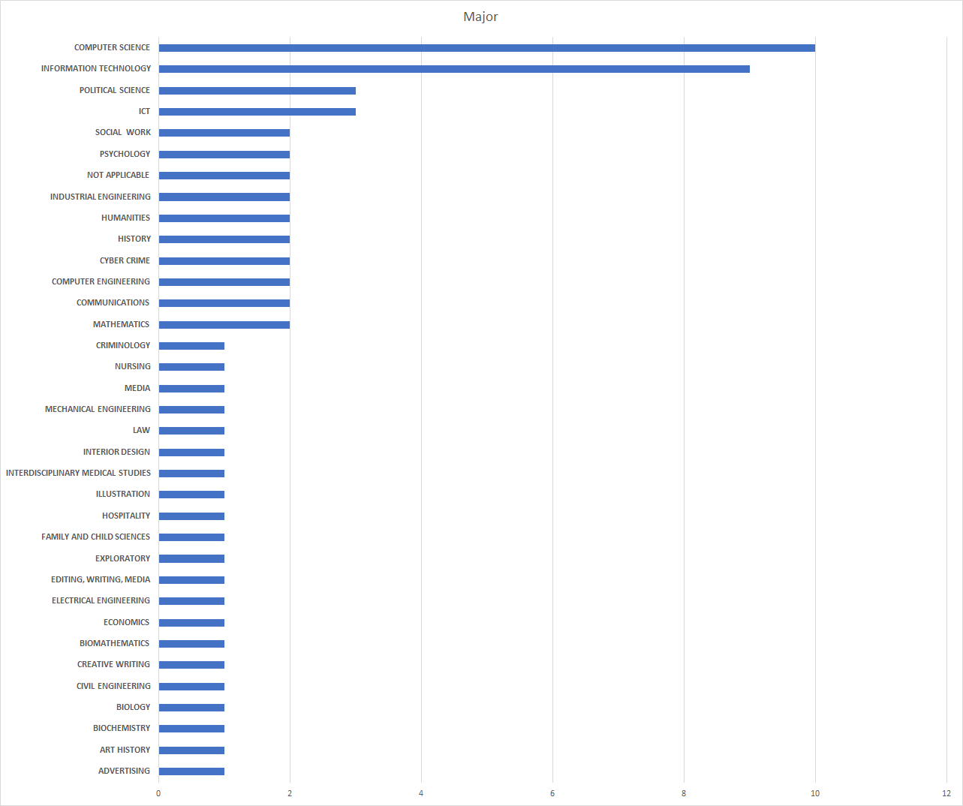

| **Have you taken a STEM course?** | **% of population** |
| --- | --- |
| Yes | 80.00% |
| No | 20.00% |

| **If you have not taken a STEM Course, would you be interested in taking one in the future?** | **% of population** |
| --- | --- |
| Yes | 25.00% |
| No | 75.00% |

| **If you have not taken a STEM course, what reason(s) did you have for not taking a STEM course?** | **% of population** |
| --- | --- |
| Not interested | 46.67% |
| Did not apply to my major/minor | 53.33% |
| Too difficult | 0% |
| Other | 0% |

| **If you are taking a STEM course, what motivated you to take that course?** | **% of population** |
| --- | --- |
| Needed for major/minor | 52.31% |
| Personal interest | 24.62% |
| Good job opportunities | 23.08% |
| Other | 0% |

**If you have taken a STEM course, did you feel represented by the demographic of your classmates? (Why/Why not)**

* 57% of female respondents felt that they were not represented by their demographic in STEM classes
* 73% of male respondents felt represented by their demographic in STEM classes
  + Men also had a tendency to comment on a disparity in ethnicity rather than gender

| **Have you heard of the term “Digital Divide”** | **% of population** |
| --- | --- |
| Yes | 32.69% |
| No | 67.31% |

**What percentage of STEM majors do you believe are women?**

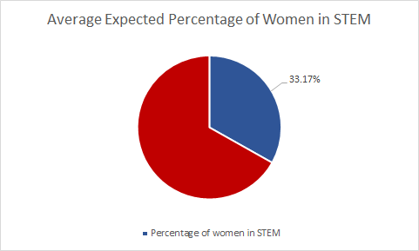

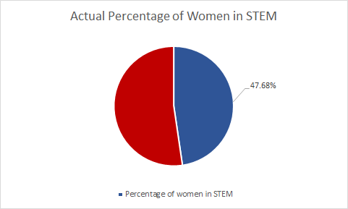

| **In your experience, do you feel as if FSU has provided assistance/guidance to promote STEM courses?** | **% of population** |
| --- | --- |
| Yes | 47.22% |
| No | 52.78% |

| **On a scale from 1 (Strongly Disagree) to 5 (Strongly Agree), do you believe FSU’s STEM programs value diversity?** |  |
| --- | --- |
| Average | 3.33 |
| Standard Deviation | 1.03 |

| **On a scale from 1 (Not Very) to 5 (Very), how strongly do you feel about actively increasing women's participation and involvement in STEM programs at FSU?** |  |
| --- | --- |
| Average | 4.06 |
| Standard Deviation | 1.10 |

**Do you ever feel at a disadvantage or not given equal access to within STEM (why or why not?)**

* 17% of respondents claimed they felt they were at a disadvantage in regards to their ability to access resources
  + 70% of females felt they had equal access
  + 93% of males felt they had equal access

| **Do you believe that STEM programs are at a disadvantage because of the limited number of women enrolled in their programs?** | % of population |
| --- | --- |
| Yes | 66.67% |
| No | 33.33% |

**Visualizations, Findings, and Discussions**

RQ 1:

RQ 2:

# **References**

Using APA 7th Style. You need to incorporate the comments from instructors and highlight your changes.

Barboni G., Field E., Pande R., Rigol N., Schaner S., Moore C. T. (2018). *A tough call: understanding barriers to and impacts of women’s mobile phone adoption in India*. Harvard Kennedy School. https://www.hks.harvard.edu/publications/tough-call-understanding-barriers-and-impacts-womens-mobile-phone-adoption-india

Brown, J. (2021). *Creating a culture of diversity, equity, and inclusion: Real progress requires sustained commitment*. Harvard Business Review Analytic Services. https://hbr.org/sponsored/2021/09/creating-a-culture-of-diversity-equity-and-inclusion

Ice, L., & Zilberman, A. (2021). *Why computer occupations are behind strong STEM employment growth in the 2019–29 decade* (Beyond the Numbers: Employment & Unemployment, Series 10, Issue 1)*.* U.S. Bureau of Labor Statistics. <https://www.bls.gov/opub/btn/volume-10/pdf/why-computer-occupations-are-behind-strong-stem-employment-growth.pdf>

Joel Cooper, & Kimberlee D. Weaver. (2003). *Gender and computers: understanding the digital divide.* Psychology Press. https://web-a-ebscohost-com.proxy.lib.fsu.edu/ehost/ebookviewer/ebook?sid=1c502e0c-02ba-4419-bed3-775ad2be1b8a%40sessionmgr4007&vid=0&format=EB

KewalRamani, A., Zhang, J., Wang, X., Rathbun, A., Corcoran, L., Diliberti, M., & Zhang, J. (2018). *Student access to digital learning resources outside of the classroom* (NCES Publication No. 2017-098). U.S. Department of Education: National Center for Education Statistics. <https://nces.ed.gov/pubs2017/2017098.pdf>

Liff, S., & Shepherd, A. (2004). An evolving gender digital divide? *Oxford Internet Institute.* Internet Brief No. 2.

Lund, S., Manyika, J., Segel, L. H., Dua, A., Hancock, B., Rutherford, S., Macon, B. (2019). *The future of work in America: people and places, today and tomorrow*. McKinsey Global Institute. https://www.mckinsey.com/featured-insights/future-of-work/the-future-of-work-in-america-people-and-places-today-and-tomorrow

Mostafa, T. (2019). *Why don’t more girls choose to pursue a science career?* (PISA in Focus, Issue 93). Organisation for Economic Cooperation and Development Publishing. https://doi.org/10.1787/02bd2b68-en.

World Economic Forum. (2020). *The future of jobs report 2020*. <https://www.weforum.org/reports/the-future-of-jobs-report-2020/in-full/>

**Consent Form**

Note: Use the table below to document each team member’s contribution to this assignment.

| Name | Contribution |
| --- | --- |
| Jamel Douglas | Contributed to editing the “Data Collection Methods”, participated in discussions with the group |
| Daniel Jaramillo | Contributed to the creation of the data analysis and collection tables and graphics |
| Brennan O’Hara | Contributed to editing the “Problem Statement”, Participated in discussions with the group |
| Vanessa Sanbria | Contributed to editing the “Significance of Study”, proofread other sections, participated in vocal discussion |
| Deven Ugalde | Contributed to editing the “Population and Sample” and “Recruitment Site and Strategy” sections, participated in vocal discussion |
| Oliver Veras | Contributed to editing the “Demographic Description”, participated in discussions with the group, and proofread/edited other sections |

| Criteria | Rating |
| --- | --- |
| Appropriateness of the research problem and significance: in-text citations for all arguments (2 pts); appropriate problem statement, significance and RQ formation (4 pts); incorporating comments from previous PR (2 pts) |  |
| Completeness of the environmental scan: appropriate intro, subsections, and conclusion (3 pts), in-text citations for all arguments (2 pts); incorporating comments from previous IES and GES (2 pts) |  |
| Data collection plan: finalized choice of data collection method and sampling techniques, no need for comparison (3 pts), appropriate data collection methods and sampling techniques (3 pts), detailed recruitment site and strategy, and timeline (2 pts); incorporating comments from previous PR (2 pts) |  |
| Data analysis, visualization, and discussion: demographic description (4 pts), appropriate discussion for each RQ (6 pts), visualizations (5 pts) |  |
| Format: file name (1 pt); APA regarding visualizations, in-text citations, and references (5 pts); match between in-text citation and references (3 pts), consent form (1 pt) |  |